MEN (500, 1500, 5000, 10000)
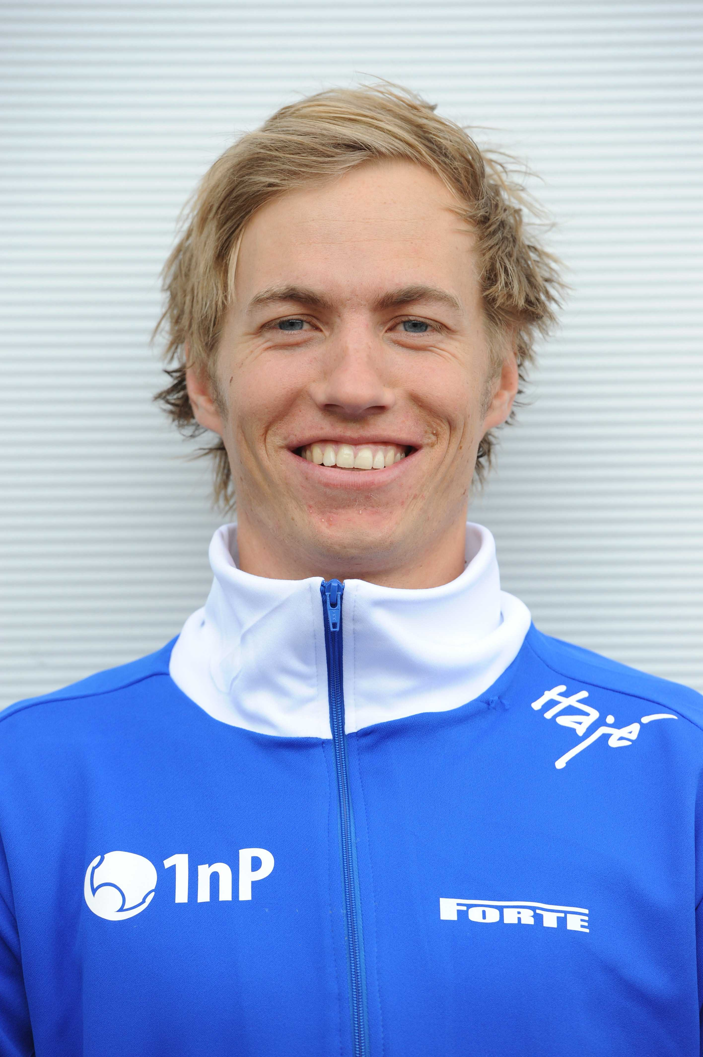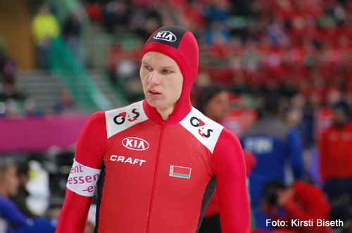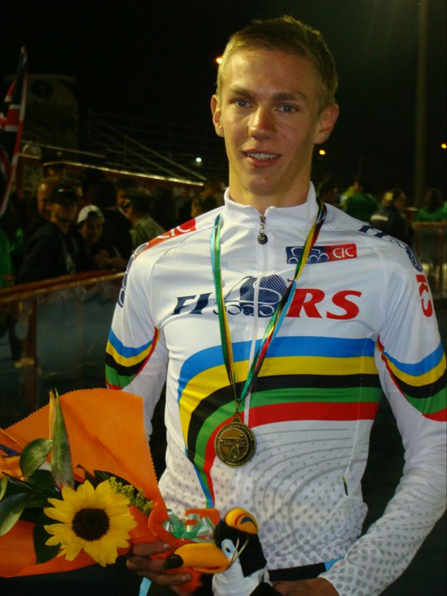
AUSTRIA
Bram Smallenbroek (27.02.1987)
PB:
500m 36,88 23 January 2010 Heerenveen (NED)
1500m 1.49,73 16 October 2011 Inzell (GER)
5000m 6.44,33 29 October 2011 Erfurt (GER)
10000m 15.05,64 18 December 2011 Innsbruck (AUT)
2011/2012:
500m 37,49 29 December 2011 Inzell (GER)
1500m 1.49,73 16 October 2011 Inzell (GER)
5000m 6.44,33 29 October 2011 Erfurt (GER)
10000m 15.05,64 18 December 2011 Innsbruck (AUT)
BELARUSSIA
Vitaly Mikhailov (24.08.1986)
PB:
500m 36,48 9 November 2007 Salt Lake City (USA)
1500m 1.47,45 9 November 2007 Salt Lake City (USA)
5000m 6.26,09 17 November 2007 Calgary (CAN)
10000m 13.57,22 25 November 2007 Calgary (CAN)
2011/2012:
500m 37,24 17 December 2011 Minsk (BLR)
1500m 1.50,36 16 October 2011 Inzell (GER)
5000m 6.38,37 26 November 2011 Astana (KAZ)
10000m 14.07,24 18 December 2011 Minsk (BLR)
BELGIUM
Bart Swings (12.02.1991)
PB:
500m 38,01 30 December 2011 Erfurt (GER)
1500m 1.49,24 25 November 2011 Astana (KAZ)
5000m 6.24,58 26 November 2011 Astana (KAZ)
10000m 13.23,99 19 February 2011 Salt Lake City (USA)
2011/2012:
500m 38,01 30 December 2011 Erfurt (GER)
1500m 1.49,24 25 November 2011 Astana (KAZ)
5000m 6.24,58 26 November 2011 Astana (KAZ)
10000m 13.33,44 3 December 2011 Heerenveen (NED)
Ferre Spruyt (09.04.1986)
PB:
500m 39,47 30 December 2011 Erfurt (GER)
1500m 1.56,99 16 October 2011 Inzell (GER)
5000m 6.37,60 26 November 2011 Astana (KAZ)
10000m 13.53,90 18 March 2011 Calgary (CAN)
2011/2012:
500m 39,47 30 December 2011 Erfurt (GER)
1500m 1.56,99 16 October 2011 Inzell (GER)
5000m 6.37,60 26 November 2011 Astana (KAZ)
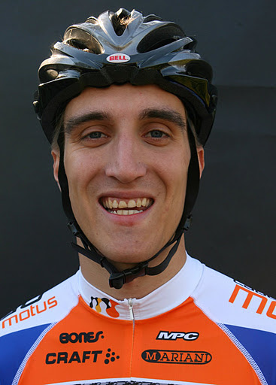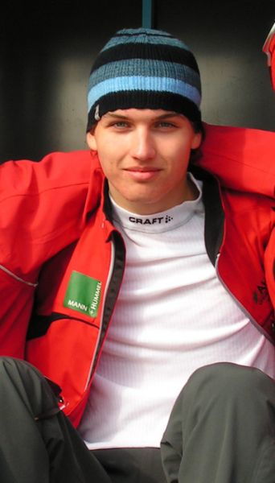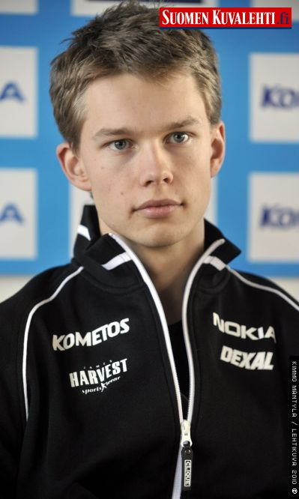
CZECH REPUBLIK
Zdenek Haselberger (19.05.1989)
PB:
500m 38,23 6 November 2011 Calgary (CAN)
1500m 1.51,21 5 November 2011 Calgary (CAN)
5000m 6.42,17 26 November 2011 Astana (KAZ)
10000m 14.09,28 28 October 2007 Calgary (CAN)
2011/2012:
500m 38,23 6 November 2011 Calgary (CAN)
1500m 1.51,21 5 November 2011 Calgary (CAN)
5000m 6.42,17 26 November 2011 Astana (KAZ)
FINNLAND
Tommi Pulli (18.07.1992)
PB:
500m 35,70 19 March 2011 Calgary (CAN)
1500m 1.45,82 20 March 2011 Calgary (CAN)
5000m 6.46,61 16 March 2011 Calgary (CAN)
10000m 16.05,15 11 December 2011 Helsinki (FIN)
2011/2012:
500m 36,12 12 November 2011 Erfurt (GER)
1500m 1.50,82 2 December 2011 Heerenveen (NED)
5000m 7.32,50 10 December 2011 Helsinki (FIN)
10000m 16.05,15 11 December 2011 Helsinki (FIN)

FRANCE
Alexis Contin (19.10.1986)
OG:
2010 5000 6, 10000 4
PB:
500m 36,66 12 February 2011 Calgary (CAN)
1500m 1.44,73 4 December 2009 Calgary (CAN)
5000m 6.15,74 12 December 2009 Salt Lake City (USA)
10000m 13.12,11 23 February 2010 Richmond (CAN)
2011/2012:
500m 37,33 29 October 2011 Inzell (GER)
1500m 1.47,16 25 November 2011 Astana (KAZ)
5000m 6.17,43 26 November 2011 Astana (KAZ)
10000m 13.14,72 3 December 2011 Heerenveen (NED)
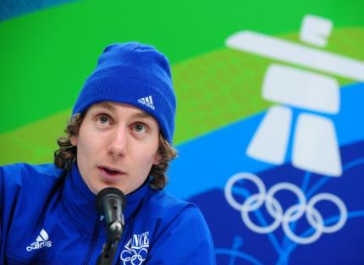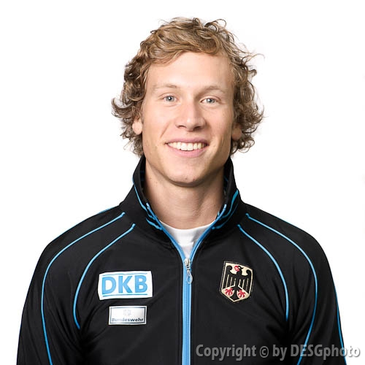
Benjamin Mace (16.05.1989)
OG:
2010. Shorttrack 1500 22, 5000 relay 5
PB:
500m 37,27 21 October 2011 Inzell (GER)
1500m 1.46,68 2 December 2011 Heerenveen (NED)
5000m 6.43,92 29 January 2011 Moscow (RUS)
2011/2012:
500m 37,27 21 October 2011 Inzell (GER)
1500m 1.46,68 2 December 2011 Heerenveen (NED)
5000m 6.45,94 21 October 2011 Inzell (GER)
GERMANY
Moritz Geisreiter (30.12.1987)
OG:
2010. 22. 5000
PB:
500m 38,27 19 March 2011 Calgary (CAN)
1500m 1.48,67 25 November 2011 Astana (KAZ)
5000m 6.19,31 26 November 2011 Astana (KAZ)
10000m 13.16,12 19 February 2011 Salt Lake City (USA)
2011/2012:
500m 38,55 30 December 2011 Inzell (GER)
1500m 1.48,67 25 November 2011 Astana (KAZ)
5000m 6.19,31 26 November 2011 Astana (KAZ)
10000m 13.17,24 3 December 2011 Heerenveen (NED)
Patrick Beckert (17.04.1990)
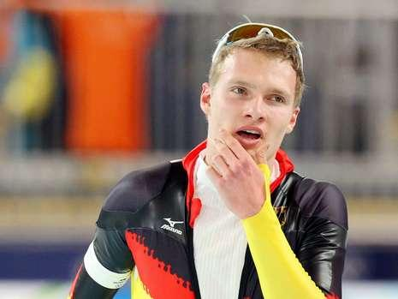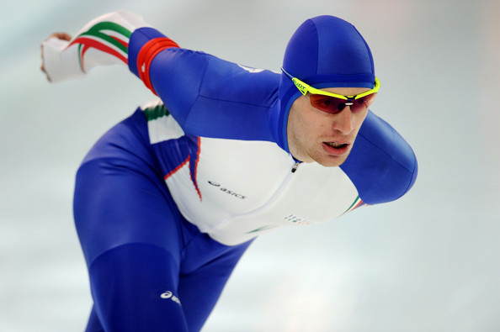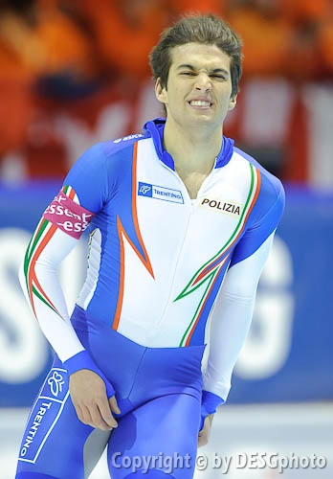
PB:
500m 37,89 9 January 2010 Hamar (NOR)
1500m 1.48,49 5 November 2011 Inzell (GER)
5000m 6.19,82 12 December 2009 Salt Lake City (USA)
10000m 13.08,54 19 February 2011 Salt Lake City (USA)
2011/2012:
500m 38,20 30 December 2011 Erfurt (GER)
1500m 1.48,49 5 November 2011 Inzell (GER)
5000m 6.25,29 26 November 2011 Astana (KAZ)
10000m 13.24,36 3 December 2011 Heerenveen (NED)
ITALIA
Luca Stefani (22.02.1987)
OG:
2010 5000 25.
PB:
500m 36,72 12 February 2011 Calgary (CAN)
1500m 1.48,20 11 March 2007 Salt Lake City (USA)
5000m 6.20,71 5 December 2009 Calgary (CAN)
10000m 13.38,33 15 February 2009 Heerenveen (NED)
2011/2012:
500m 37,07 17 December 2011 Baselga di Pinè (ITA)
1500m 1.51,44 2 December 2011 Heerenveen (NED)
5000m 6.40,34 19 November 2011 Tsjeljabinsk (RUS)
10000m 13.53,17 3 December 2011 Heerenveen (NED)

Marco Cignini (22.06.1989)
PB:
500m 37,63 9 January 2009 Heerenveen (NED)
1500m 1.48,49 11 December 2009 Salt Lake City (USA)
5000m 6.40,17 19 November 2010 Berlin (GER)
10000m 14.22,76 19 December 2010 Collalbo (ITA)
2011/2012:
500m 37,92 29 December 2011 Collalbo (ITA)
1500m 1.52,51 16 October 2011 Inzell (GER)
5000m 6.49,61 19 November 2011 Inzell (GER)
10000m 14.28,62 18 December 2011 Baselga di Pinè (ITA)
LATVIA
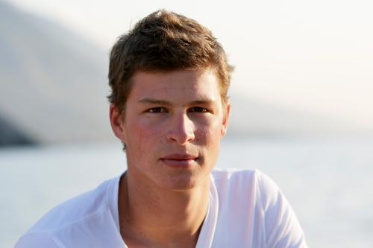
Haralds Silovs (07.04.1986)
ECh: shorttrack
2008. Overall 1, 1500 1
2009: 1500 1
PB:
500m 36,76 23 January 2011 Heerenveen (NED)
1500m 1.45,90 11 December 2009 Salt Lake City (USA)
5000m 6.17,13 12 December 2009 Salt Lake City (USA)
2011/2012:
500m 37,24 16 October 2011 Inzell (GER)
1500m 1.49,10 16 October 2011 Inzell (GER)
5000m 6.30,42 26 November 2011 Astana (KAZ)
NEEDERLAND
Sven Kramer (23.04.1986)
OG:
2006 5000 2, team pursuit 3
2010 5000 1, team pursuit 3
ECh:Allround
2005 2
2007-2009 1
WCh junioren
2004 2,
2005 1. team pursuit
WCh. Allround
2005 – 2066 3
2007 – 2010 1
WCh:
2007 5000 1, 1000 1, team pursuit 1
2008 1500 2, 5000 1, 1000 1, team pursuit 1
2009 5000 1, 10000 1m team pursuit 1

PB:
500m 36,17 27 December 2009 Heerenveen (NED)
1500m 1.43,54 11 December 2009 Salt Lake City (USA)
5000m 6.03,32 17 November 2007 Calgary (CAN) WR
10000m 12.41,69 10 March 2007 Salt Lake City (USA) WR
2011/2012:
500m 37,19 13 November 2011 Heerenveen (NED)
1500m 1.47,33 27 December 2011 Heerenveen (NED)
5000m 6.13,83 26 November 2011 Astana (KAZ)
10000m 13.09,96 6 November 2011 Heerenveen (NED)
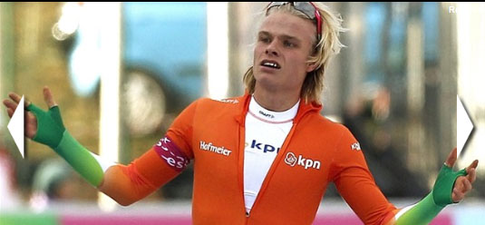
Koen Verweij (26.08.1990)
ECh Allround
2011 3.
WCh:Junioren
2008 2., Team Pursuit 1
2009 1., Team Pursuit 1
2010 1., Team Pursuit 1
WCh: Junioren
2009 5000 1
2010 1000 3, 1500 2, 5000m 1
WCh:
2011 Team Pursuit 3
PB:
500m 35,64 12 February 2011 Calgary (CAN)
1500m 1.43,92 13 February 2011 Calgary (CAN)
5000m 6.12,20 12 February 2011 Calgary (CAN)
10000m 13.08,97 13 February 2011 Calgary (CAN)
2011/2012:
500m 36,97 17 December 2011 Erfurt (GER)
1500m 1.47,83 27 December 2011 Heerenveen (NED)
5000m 6.23,84 28 December 2011 Heerenveen (NED)

Jan Blokhuijsen (01.04.1989)
OG:
2010 5000 9, team pursuit 3
WCh Junioren
2008 1, team Pursuit 1
ECh Allround:
2011 2
WCh Allround
2011 3
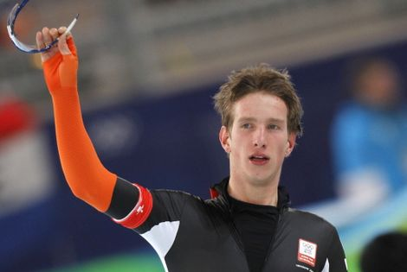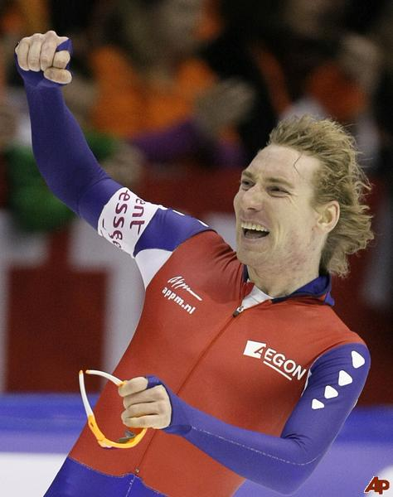
PB:
500m 35,59 12 February 2011 Calgary (CAN)
1500m 1.43,78 13 February 2011 Calgary (CAN)
5000m 6.14,18 12 February 2011 Calgary (CAN)
10000m 13.00,04 13 February 2011 Calgary (CAN)
2011/2012:
500m 36,42 17 December 2011 Erfurt (GER)
1500m 1.47,34 6 November 2011 Heerenveen (NED)
5000m 6.18,78 26 November 2011 Astana (KAZ)
10000m 13.15,14 6 November 2011 Heerenveen (NED)

Ted-Jan Bloemen (16.08.1986)
WCh Junioren
2006 Team Pursuit 1
ECh Allround
2008 8
WChAllround
2010 4
PB:
500m 36,87 19 March 2010 Heerenveen (NED)
1500m 1.46,52 19 March 2009 Calgary (CAN)
5000m 6.17,07 7 March 2009 Salt Lake City (USA)
10000m 13.11,79 15 March 2007 Calgary (CAN)
2011/2012:
500m 37,62 9 July 2011 Heerenveen (NED)
1500m 1.48,31 27 December 2011 Heerenveen (NED)
5000m 6.22,38 28 December 2011 Heerenveen (NED)
10000m 13.36,04 6 November 2011 Heerenveen (NED)

NORGE
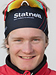
Havard Bokko (02.02.1987)
OG:
2010 5000 4., 1000 19., 1500 3., 10000 5
PB:
500m 35,86 28 February 2009 Salt Lake City (USA)
1500m 1.42,67 6 March 2009 Salt Lake City (USA)
5000m 6.09,94 7 March 2009 Salt Lake City (USA)
10000m 12.53,89 13 February 2011 Calgary (CAN)
2011/2012:
500m 36,79 16 October 2011 Hamar (NOR)
1500m 1.45,97 25 November 2011 Astana (KAZ)
5000m 6.17,88 26 November 2011 Astana (KAZ)
10000m 13.05,55 3 December 2011 Heerenveen (NED)
Sverre Lunde Pedersen (17.07.1992)
PB:
500m 36,56 12 February 2011 Calgary (CAN)
1500m 1.45,48 13 February 2011 Calgary (CAN)
5000m 6.22,83 12 February 2011 Calgary (CAN)
10000m 14.08,77 6 November 2011 Stavanger (NOR)
2011/2012:
500m 37,21 30 December 2011 Inzell (GER)
1500m 1.47,55 25 November 2011 Astana (KAZ)
5000m 6.24,44 26 November 2011 Astana (KAZ)
10000m 14.08,77 6 November 2011 Stavanger (NOR)
Kristian Reistad Fredriksen (10.05.1993)
PB:
500m 37,07 30 December 2011 Inzell (GER)
1500m 1.49,65 30 December 2011 Inzell (GER)
5000m 6.33,14 26 November 2011 Astana (KAZ)
10000m 14.24,22 19 December 2010 Oslo - Frogner (NOR)
2011/2012:
500m 37,07 30 December 2011 Inzell (GER)
1500m 1.49,65 30 December 2011 Inzell (GER)
5000m 6.33,14 26 November 2011 Astana (KAZ)
10000m 14.35,50 6 November 2011 Stavanger (NOR)

Simen Spieler Nilsen (04.08.1993)
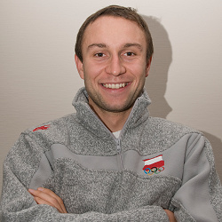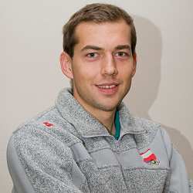
PB:
500m 37,14 12 November 2011 Erfurt (GER)
1500m 1.50,79 30 December 2011 Inzell (GER)
5000m 6.43,32 13 March 2010 Moscow (RUS)
10000m 14.55,46 19 December 2010 Oslo - Frogner (NOR)
2011/2012:
500m 37,14 12 November 2011 Erfurt (GER)
1500m 1.50,79 30 December 2011 Inzell (GER)
5000m 7.09,52 17 December 2011 Tønsberg (NOR)
POLAND
Konrad Niedzwiedzki (01.02.1985)
OG:
2010: 1500 17., 1000 27., 500 32
PB:
500m 35,29 4 December 2009 Calgary (CAN)
1500m 1.43,71 11 December 2009 Salt Lake City (USA)
5000m 6.29,14 18 March 2006 Calgary (CAN)
10000m 13.51,95 19 March 2006 Calgary (CAN)
2011/2012:
500m 36,37 15 October 2011 Inzell (GER)
1500m 1.47,72 16 October 2011 Inzell (GER)
5000m 6.50,05 30 October 2011 Erfurt (GER)
Zbigniew Bródka (08.10.1984)
OG:
2010 1500 27
PB:
500m 36,49 31 December 2010 Zakopane (POL)
1500m 1.45,48 4 December 2009 Calgary (CAN)
5000m 6.36,67 12 December 2009 Salt Lake City (USA)
10000m 14.53,30 17 January 2010 Zakopane (POL)
2010/2011:
500m 36,76 16 December 2011 Zakopane (POL)
1500m 1.47,26 2 December 2011 Heerenveen (NED)
5000m 6.55,97 30 October 2011 Erfurt (GER)

Jan Szymański (02.03.1989)
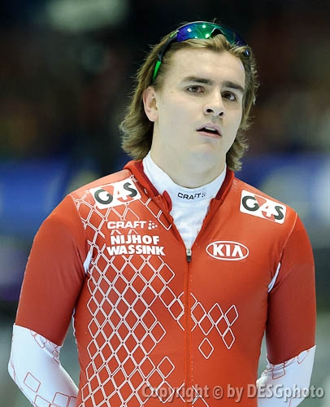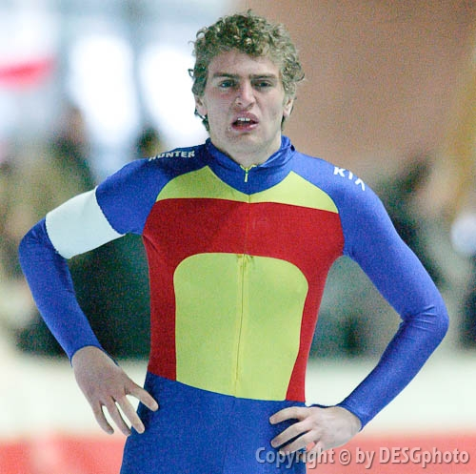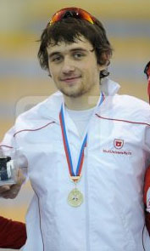
PB:
500m 36,91 12 February 2011 Calgary (CAN)
1500m 1.46,89 13 February 2011 Calgary (CAN)
5000m 6.27,85 29 January 2011 Moscow (RUS)
10000m 13.33,17 19 February 2011 Salt Lake City (USA)
2011/2012:
500m 37,83 15 October 2011 Inzell (GER)
1500m 1.51,24 25 November 2011 Astana (KAZ)
5000m 6.34,78 19 November 2011 Tsjeljabinsk (RUS)
10000m 14.04,23 3 December 2011 Heerenveen (NED)
ROUMANIA
Marion Cristian Ion (14.09.1988)
PB:
500m 38,59 16 December 2011 Inzell (GER)
1500m 1.51,62 16 November 2007 Calgary (CAN)
5000m 6.31,58 17 November 2007 Calgary (CAN)
10000m 14.04,94 23 November 2008 Moscow (RUS)
2011/2012:
500m 38,59 16 December 2011 Inzell (GER)
1500m 1.52,80 4 November 2011 Calgary (CAN)
5000m 6.46,52 6 November 2011 Calgary (CAN)

RUSSIA
Denis Yuskov (08.10.1989)
PB:
500m 37,38 22 December 2011 Moscow (RUS)
1500m 1.48,57 2 December 2011 Heerenveen (NED)
5000m 6.29,72 26 November 2011 Astana (KAZ)
10000m 13.26,94 3 December 2011 Heerenveen (NED)
2011/2012:
500m 37,38 22 December 2011 Moscow (RUS)
1500m 1.48,57 2 December 2011 Heerenveen (NED)
5000m 6.29,72 26 November 2011 Astana (KAZ)
10000m 13.26,94 3 December 2011 Heerenveen (NED)

Evgenniy Lalenkov (16.02.1981, Kiev)
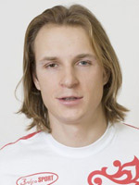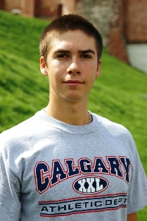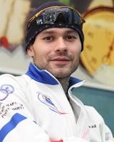
OG:
2002. 23. 1000, 10. 1500
2006. 5. Team Pursiet , 7. 1000, 23. 1500
2010. 36. 500, 11. 1000, 1500
PB:
500m 35,47 11 December 2009 Salt Lake City (USA)
1500m 1.43,16 9 November 2007 Salt Lake City (USA)
5000m 6.31,59 17 November 2007 Calgary (CAN)
10000m 13.55,36 16 December 2007 Kolomna (RUS)
2011/2012:
500m 36,40 22 December 2011 Moscow (RUS)
1500m 1.47,87 2 December 2011 Heerenveen (NED)
5000m 6.42,03 22 December 2011 Moscow (RUS)
10000m 14.18,42 23 December 2011 Moscow (RUS)
Sergei Gryazlov (26.07.1986)
PB:
500m 37,08 25 March 2010 Moscow (RUS)
1500m 1.49,71 27 December 2009 Kolomna (RUS)
5000m 6.45,56 10 November 2007 Salt Lake City (USA)
10000m 14.11,36 7 March 2010 Moscow (RUS)
2011/2012:
500m 37,45 22 December 2011 Moscow (RUS)
1500m 1.51,25 27 October 2011 Kolomna (RUS)
5000m 6.47,19 22 December 2011 Moscow (RUS)
10000m 14.13,92 1 December 2011 Tsjeljabinsk (RUS)
Pavel Bainov (13.01.1983)
PB:
500m 36,55 12 February 2011 Calgary (CAN)
1500m 1.46,19 18 February 2011 Salt Lake City (USA)
5000m 6.35,66 12 February 2011 Calgary (CAN)
10000m 13.40,61 19 February 2011 Salt Lake City (USA)
2011/2012:
500m 37,20 22 December 2011 Moscow (RUS)
1500m 1.50,61 27 October 2011 Kolomna (RUS)
5000m 6.48,57 28 October 2011 Kolomna (RUS)
10000m 14.40,08 23 December 2011 Moscow (RUS)

SUISSE
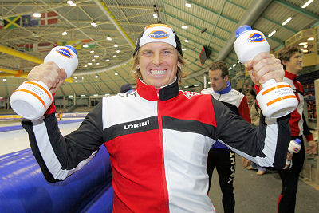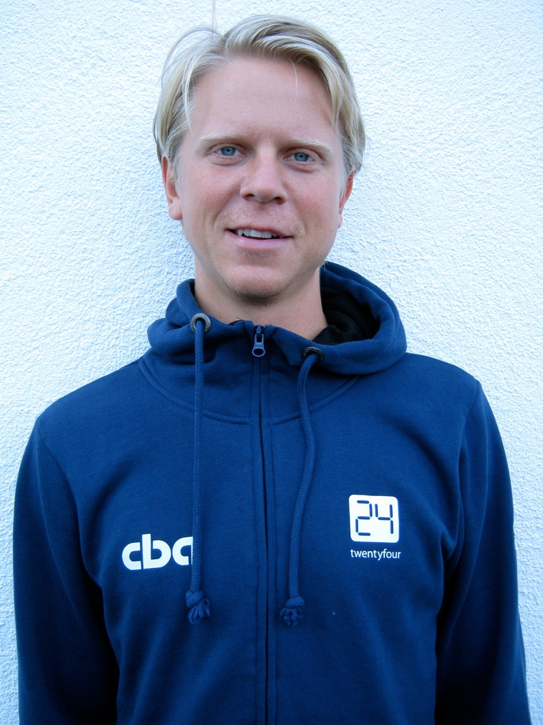
Martin Hanggi (17.03.1968)
PB:
500m 38,47 14 January 2006 Hamar (NOR)
1500m 1.54,32 13 January 2007 Collalbo (ITA)
5000m 6.43,83 26 November 2011 Astana (KAZ)
10000m 14.21,12 17 February 2007 Erfurt (GER)
2011/2012:
500m 39,38 30 October 2011 Inzell (GER)
1500m 1.56,34 22 October 2011 Inzell (GER)
5000m 6.43,83 26 November 2011 Astana (KAZ)

SWEDEN
Joel Eriksson (16.09.1984)
PB:
500m 35,95 11 December 2009 Salt Lake City (USA)
1500m 1.43,90 11 December 2009 Salt Lake City (USA)
5000m 6.27,98 17 November 2007 Calgary (CAN)
10000m 14.13,68 10 January 2010 Hamar (NOR)
2011/2012:
500m 36,38 29 October 2011 Inzell (GER)
1500m 1.48,35 30 October 2011 Inzell (GER)
5000m 6.54,54 4 November 2011 Stavanger (NOR)

Sub.
CZECH REPUBLIK
Milan Sablik (14.03.1991)
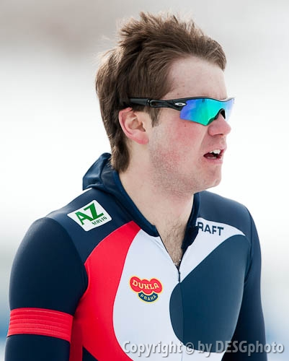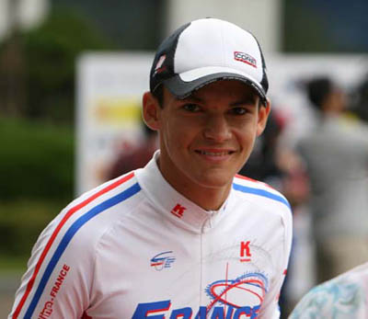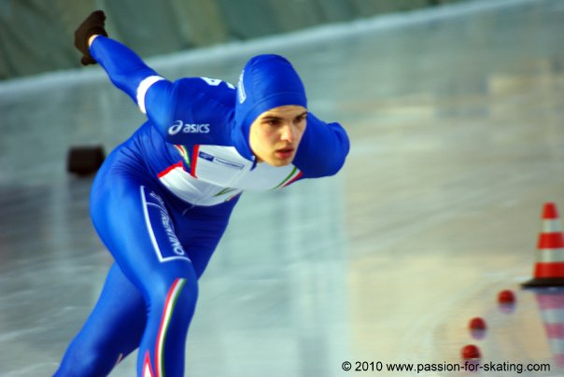
PB:
500m 37,31 4 March 2011 Inzell (GER)
1500m 1.49,03 11 December 2009 Salt Lake City (USA)
5000m 6.41,70 17 November 2007 Calgary (CAN)
10000m 14.04,71 2 December 2007 Kolomna (RUS)
2011/2012:
500m 37,59 4 November 2011 Calgary (CAN)
1500m 1.50,26 5 November 2011 Calgary (CAN)
5000m 6.52,24 6 November 2011 Calgary (CAN)
FRANCE
Ewen Fernandez (17:02.1989)
PB:
1500m 1.55,23 16 October 2011 Inzell (GER)
5000m 6.32,16 19 November 2011 Tsjeljabinsk (RUS)
10000m 13.55,08 3 December 2011 Heerenveen (NED)
2011/2012:
1500m 1.55,23 16 October 2011 Inzell (GER)
5000m 6.32,16 19 November 2011 Tsjeljabinsk (RUS)
10000m 13.55,08 3 December 2011 Heerenveen (NED)

ITALIA
Andrea Giovannini (27.08.1993)
PB:
500m 37,37 15 March 2011 Calgary (CAN)
1500m 1.50,32 16 March 2011 Calgary (CAN)
5000m 6.40,23 17 March 2011 Calgary (CAN)
10000m 15.04,54 18 December 2011 Baselga di Pinè (ITA)
2011/2012:
500m 37,44 17 December 2011 Baselga di Pinè (ITA)
1500m 1.55,06 13 November 2011 Erfurt (GER)
5000m 7.06,51 17 December 2011 Baselga di Pinè (ITA)
10000m 15.04,54 18 December 2011 Baselga di Pinè (ITA)
NEEDERLAND
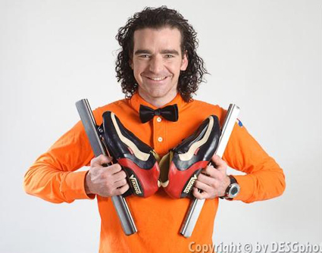
Bob de Jong (R) (13.11.1976)
OG:
1998 5000m 4, 10000m 2
2002 5000m 3, 10000m 15
2006 5000m 6, 10000m 1
2010 5000m 5, 10000m 3
WChJunioren
1995 1
1996 1
WCh
1997 10000 3
1998 10000 2
1999 5000 3, 10000 1
2000 5000 2, 10000 2
2001 5000 1, 10000 2
2003 5000 2, 10000 1
2004 10000 2
2005 5000m 2, 10000m 1
2008 10000m 3
2009 10000m 3
2011 5000m 1, 10000m 1
PB:
500m 37,86 15 March 2001 Calgary (CAN)
1500m 1.48,22 17 March 2001 Calgary (CAN)
5000m 6.08,76 12 December 2009 Salt Lake City (USA)
10000m 12.48,20 12 March 2011 Inzell (GER)
2011/2012:
1500m 1.51,24 27 December 2011 Heerenveen (NED)
5000m 6.17,92 28 December 2011 Heerenveen (NED)
10000m 12.55,11 3 December 2011 Heerenveen (NED)
NORGE
Fredrik van der Horst (02.12.1989)
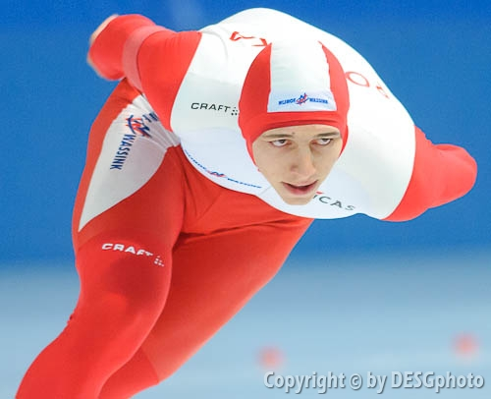
OG:
2010. 1500 29
PB:
500m 36,70 29 December 2009 Hamar (NOR)
1500m 1.47,32 11 December 2009 Salt Lake City (USA)
5000m 6.27,87 12 December 2009 Salt Lake City (USA)
10000m 13.39,48 3 December 2011 Heerenveen (NED)
2011/2012:
500m 37,86 19 November 2011 Hamar (NOR)
1500m 1.54,08 5 November 2011 Stavanger (NOR)
5000m 6.53,23 4 November 2011 Stavanger (NOR)
10000m 13.39,48 3 December 2011 Heerenveen (NED)

POLAND
Roland Cieślak (21.01.1988)
PB:
500m 37,66 11 December 2010 Zakopane (POL)
1500m 1.48,11 18 February 2011 Salt Lake City (USA)
5000m 6.33,48 12 December 2009 Salt Lake City (USA)
10000m 14.18,75 18 December 2011 Zakopane (POL)
2011/2012:
500m 38,10 15 October 2011 Inzell (GER)
1500m 1.48,65 18 November 2011 Tsjeljabinsk (RUS)
5000m 6.36,70 26 November 2011 Astana (KAZ)
10000m 14.18,75 18 December 2011 Zakopane (POL)

