WOMEN (500, 1500, 3000, 5000)
AUSTRIA
Anna Rokita (30.01.1986)
OG:
2006: 16. 3000, 27. 1500, 12. 5000
ECH Allround:
15. 2005, 2006, 2007, 2008
PB:
500m 40,63 28 November 2009 Calgary (CAN)
1500m 1.58,25 12 December 2009 Salt Lake City (USA)
3000m 4.05,17 12 November 2005 Calgary (CAN)
5000m 7.11,72 1 December 2007 Kolomna (RUS)
2011/2012:
500m 41,15 30 December 2011 Inzell (GER)
1500m 2.03,44 3 December 2011 Heerenveen (NED)
3000m 4.15,78 18 November 2011 Tsjeljabinsk (RUS)
5000m 7.19,56 2 December 2011 Heerenveen (NED)
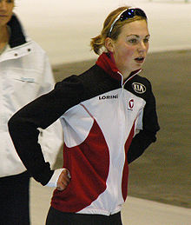

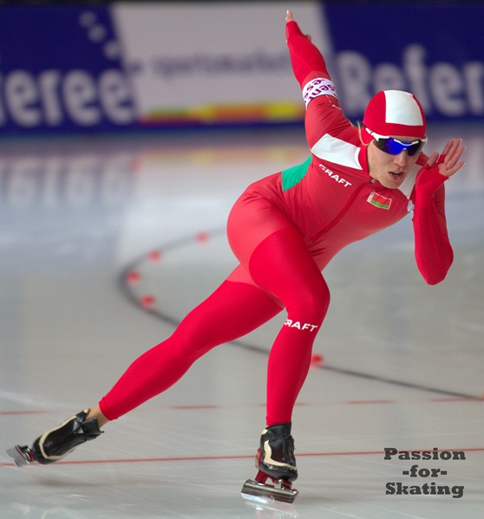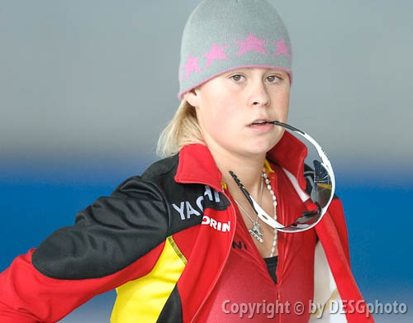
BELARUSSIA
Tatyana Mikhailova (18.01.1987)
ECh: Allround
20. 2011.
PB:
500m 40,32 12 February 2011 Minsk (BLR)
1500m 2.03,46 16 October 2011 Inzell (GER)
3000m 4.22,24 28 January 2011 Moscow (RUS)
5000m 7.36,35 18 December 2011 Minsk (BLR)
2011/2012:
500m 40,71 17 December 2011 Minsk (BLR)
1500m 2.03,46 16 October 2011 Inzell (GER)
3000m 4.22,41 18 November 2011 Tsjeljabinsk (RUS)
5000m 7.36,35 18 December 2011 Minsk (BLR)
BELGIUM
Nele Armée (14.06.1988)
PB :500m 41,94 26 October 2011 Heerenveen (NED)
1500m 2.05,73 30 October 2011 Erfurt (GER)
3000m 4.18,93 29 October 2011 Erfurt (GER)
5000m 7.27,38 30 October 2011 Erfurt (GER)
2011/2012:
500m 41,94 26 October 2011 Heerenveen (NED)
1500m 2.05,73 30 October 2011 Erfurt (GER)
3000m 4.18,93 29 October 2011 Erfurt (GER)
5000m 7.27,38 30 October 2011 Erfurt (GER)
CZEH REPUBLIC

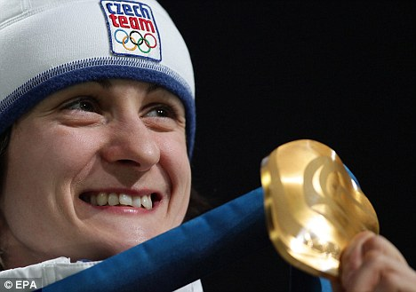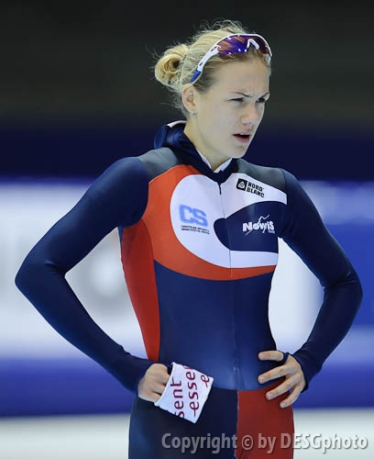
Martina Sábliková (27.05.1987)
OG:
2010 Vancouver 1. 3000 m, 1. 5000 m, 3. 1500 m
WCh:
2007 Salt Lake City 1. 3000 m, 1. 5000 m
2008 Nagano 1. 5000 m
2009 Hamar 1. Allround
2009 Vancouver 1. 5000 m, 2. 3000 m
2010 Heerenveen 1. Allround
2011 Inzell 1. 5000 m, 2. 3000 m
2011 Calgary 3. Allround
ECh:
2007 Collalbo 1. Allround
2008 Kolomna 3. Allround
2009 Heerenveen 3. Allround
2010 Hamar 1. Allround
2011 Collalbo 1. Allround
World Junior Championships
2006 Erfurt 2. Allround
PB:
500m 39,49 12 February 2011 Calgary (CAN)
1500m 1.54,55 3 March 2007 Calgary (CAN)
3000m 3.55,55 12 February 2011 Calgary (CAN)
5000m 6.42,66 18 February 2011 Salt Lake City (USA)
2011/2012:
500m 40,81 21 October 2011 Inzell (GER)
1500m 1.57,31 3 December 2011 Heerenveen (NED)
3000m 4.03,28 25 November 2011 Astana (KAZ)
5000m 6.58,87 2 December 2011 Heerenveen (NED)
Karolina Erbanová (27.10.1992)
OG:
2010. 25. 500, 12. 1000, 25. 1500
PB: 500m 38,22 12 February 2011 Calgary (CAN)
1500m 1.55,80 5 December 2009 Calgary (CAN)
3000m 4.17,73 12 February 2011 Calgary (CAN)
5000m 7.36,65 10 January 2010 Hamar (NOR)
2011/2012:
500m 38,38 3 December 2011 Heerenveen (NED)
1500m 2.01,70 19 November 2011 Tsjeljabinsk (RUS)
3000m 4.34,72 21 October 2011 Inzell (GER)

DEMNARK
Sara Bak (12.09.1982)
PB:
500m 41,94 17 November 2011 Calgary (CAN)
1500m 2.01,87 4 November 2011 Calgary (CAN)
3000m 4.16,42 20 November 2010 Berlin (GER)
5000m 7.37,50 22 November 2009 Calgary (CAN)
2011/2012:
500m 41,94 17 November 2011 Calgary (CAN)
1500m 2.01,87 4 November 2011 Calgary (CAN)
3000m 4.17,34 19 November 2011 Calgary (CAN)
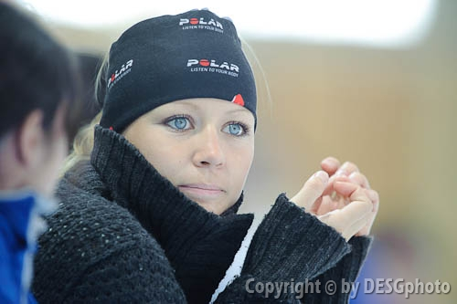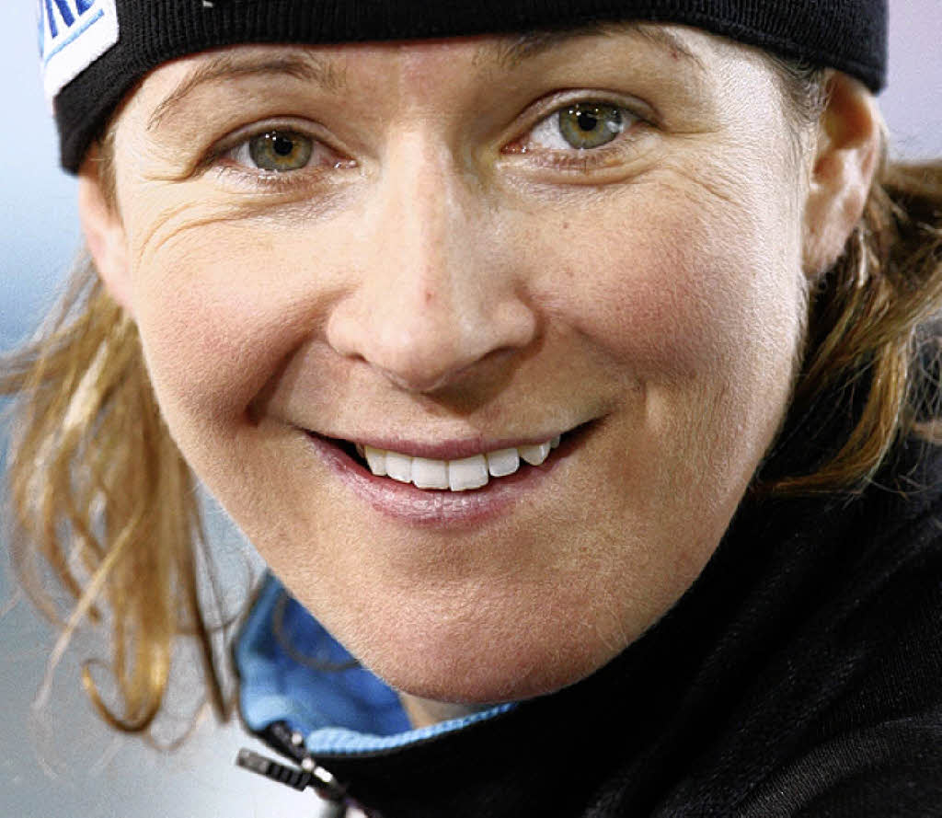

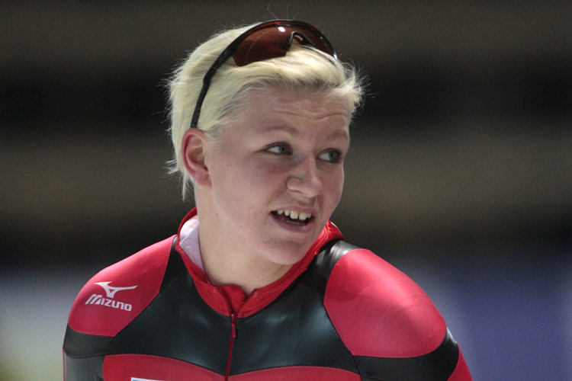

GERMANIA (3)
Claudia Pechstein (22.02 1972, Berlin)
OG:
1994 in Lillehammer 1. 5000, 3. 3000
1998 in Nagano 1. 5000, 2. 3000
2002 in Salt Lake City 1. 3000, 1. 1000
2006 in Torino, 1. team pursuit, 2. 5000
WCh:
2011. 3. 5000 , 3. Team Pursuit
2000 / 2004 1. 3000
1996 / 2003 1. 5000
2000 1. 1500
2000 1. Allround
PB:
500m 38,99 18 March 2006 Calgary (CAN)
1500m 1.54,31 17 November 2007 Calgary (CAN)
3000m 3.57,35 18 March 2006 Calgary (CAN)
5000m 6.46,91 23 February 2002 Salt Lake City (USA)
2011/2012:
500m 40,04 30 December 2011 Berlin (GER)
1500m 1.56,77 26 November 2011 Astana (KAZ)
3000m 4.03,59 25 November 2011 Astana (KAZ)
5000m 7.02,92 2 December 2011 Heerenveen (NED)
Isabell Ost (21.10.1988, Berlin)
WCh:
2001. 3. Team Pursuit
PB:
500m 40,45 12 February 2011 Calgary (CAN)
1500m 1.56,72 13 February 2011 Calgary (CAN)
3000m 4.07,51 12 February 2011 Calgary (CAN)
5000m 7.28,19 17 October 2009 Berlin (GER)
2011/2012:
500m 41,73 30 December 2011 Berlin (GER)
1500m 2.00,47 5 November 2011 Inzell (GER)
3000m 4.11,07 4 November 2011 Inzell (GER)
Bente Kraus (21.02.1989, Berlin)
ECh:
2011. 18. Allround
Junioren-WCh:
2008 2. Team pursuit
2006. 5. team pursuit
PB:
500m 40,94 15 March 2011 Calgary (CAN)
1500m 2.00,79 15 March 2011 Calgary (CAN)
3000m 4.11,47 16 March 2011 Calgary (CAN)
5000m 7.12,81 18 March 2011 Calgary (CAN)
2011/2012:
500m 42,00 30 December 2011 Erfurt (GER)
1500m 2.04,41 3 December 2011 Heerenveen (NED)
3000m 4.17,04 30 December 2011 Erfurt (GER)
5000m 7.15,50 15 October 2011 Erfurt (GER)
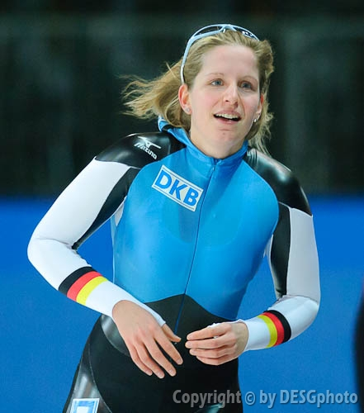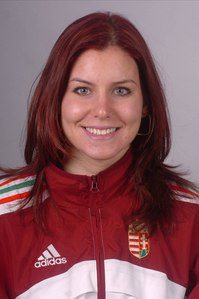
HUNGARY (1)
Tóth Ágota (08.09.1987)
PB :
500m 40,38 7 December 2003 Calgary (CAN)
1500m 2.05,95 20 November 2009 Calgary (CAN)
3000m 4.23,75 19 November 2011 Calgary (CAN)
2011/2012:
500m 42,75 3 December 2011 Budapest (HUN)
1500m 2.06,38 18 November 2011 Calgary (CAN)
3000m 4.23,75 19 November 2011 Calgary (CAN)
NEEDERLAND (4)
Ireen Wüst (01.04.1986)
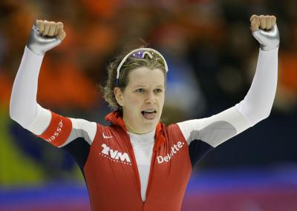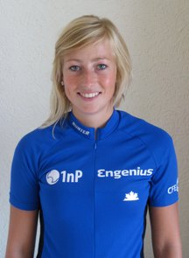
OG:
2006 4. 1000, 3. 1500, 1. 3000 6. team pursuit
2010 8. 1000, 1. 1500, 7. 3000, 6. team pursuit
WCh:
2007 Salt Lake City 1. 1000, 1. 1500, 2.team Pursuit
2008 Nagano 1. team Pursuit
2009 Richmond 2. 1500, 2. Team Pursuit
2011 Inzell 2. 1000, 1. 1500, 1. 3000, 2. team Pursuit
WCh: Allround
1. 2007, 2. 2008, 3. 2009, 3. 2010, 1. 2011
EK Allround
3. 2006, 2. 2007, 1. 2008, 2. 2010, 2. 2011
WCh:Junioren
2, 2004 Roseville, 1. Team Pursuit
1. 2005 Seinäjoki , 1. Team Pursuit
PB:
500m 38,44 9 February 2007 Heerenveen (NED)
1500m 1.52,38 3 March 2007 Calgary (CAN) NR
3000m 3.58,01 12 February 2011 Calgary (CAN)
5000m 6.55,85 13 February 2011 Calgary (CAN)
2011/2012:
500m 39,08 29 December 2011 Heerenveen (NED)
1500m 1.57,00 26 November 2011 Astana (KAZ)
3000m 4.05,38 25 November 2011 Astana (KAZ)
Annouk van der Weijden (27.06.1986)
PB:
500 meter 39,70 Calgary 22-03-2009
1500m 1.58,86 25 November 2011 Astana (KAZ)
3000m 4.06,97 26 November 2011 Astana (KAZ)
5000 meter 7.07,02 Calgary 20-03-2009
2011/2012:
500m 39,92 18 December 2011 Erfurt (GER)
1500m 1.58,86 25 November 2011 Astana (KAZ)
3000m 4.06,97 26 November 2011 Astana (KAZ)
5000m 7.07,39 2 December 2011 Heerenveen (NED)
Diane Valkenburg (30.08.1984)
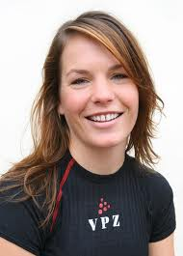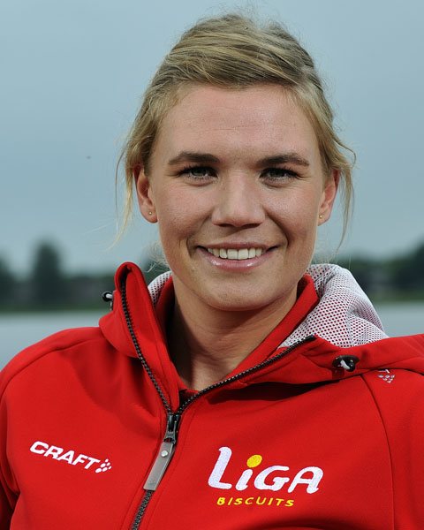
OG:
2010 Vancouver 11. 3000, 6.team Pursuit
WCh: Allround
8. 2008, 7. 2010, 8. 2011
WCh:
2011 Inzell 2. 1500m, 2. Team Pursuit
ECh: Allround
6. 2010, 4. 2011
PB:
500m 39.48 Calgary 12-02-2011
1500m 1.55.54 Calgary 13-02-2011
3000m 4.02.44 Calgary 12-02-2011
5000m 7.04.10 Calgary 13-02-2011
2011/2012:
500m 40,23 17 December 2011 Erfurt (GER)
1500m 1.57,52 26 November 2011 Astana (KAZ)
3000m 4.05,36 25 November 2011 Astana (KAZ)
5000m 7.15,37 30 December 2011 Heerenveen (NED)
Linda de Vries (04.02.1988)
PB:
500m 40,24 Heerenveen 27-12-2010
1500m 1.56,48 Salt Lake City 19-02-2011
3000m 4.07,96 Tsjeljabinsk 18-11-2011
5000m 7.10,28 Salt Lake City 18-02-2011
2011/2012:
500m 40,54 22 December 2011 Heerenveen (NED)
1500m 1.57,85 26 November 2011 Astana (KAZ)
3000m 4.07,96 18 November 2011 Tsjeljabinsk (RUS)
5000m 7.08,08 2 December 2011 Heerenveen (NED)

NORGE (3)
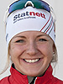


Hege Bokko (05.09.1991)
PB:
500m 39,05 12 February 2011 Calgary (CAN)
1500m 1.57,91 13 February 2011 Calgary (CAN)
3000m 4.12,81 12 February 2011 Calgary (CAN)
5000m 7.42,10 6 November 2011 Stavanger (NOR)
2011/2012:
500m 40,79 29 October 2011 Inzell (GER)
1500m 1.59,24 3 December 2011 Heerenveen (NED)
3000m 4.14,56 25 November 2011 Astana (KAZ)
5000m 7.42,10 6 November 2011 Stavanger (NOR)
Ida Njatun (06.02.1991)
PB:
500m 39,36 12 February 2011 Calgary (CAN)
1500m 1.56,25 13 February 2011 Calgary (CAN)
3000m 4.06,46 12 February 2011 Calgary (CAN)
5000m 7.09,41 18 February 2011 Salt Lake City (USA)
2011/2012:
500m 40,28 2 December 2011 Heerenveen (NED)
1500m 1.58,05 26 November 2011 Astana (KAZ)
3000m 4.08,92 25 November 2011 Astana (KAZ)
Mari Hemmer (20.11.1983)
PB:
500m 40,51 12 February 2011 Calgary (CAN)
1500m 1.57,52 19 February 2011 Salt Lake City (USA)
3000m 4.08,72 16 November 2007 Calgary (CAN)
5000m 7.01,02 18 February 2011 Salt Lake City (USA)
2011/2012:
500m 42,66 13 August 2011 Hamar (NOR)
1500m 2.02,51 3 December 2011 Heerenveen (NED)
3000m 4.22,42 13 August 2011 Hamar (NOR)
5000m 7.35,92 2 December 2011 Heerenveen (NED)

POLAND (3)
Natalia Czerwonka (20.10.1988)
OG:
2010. 3. Team Pursuit
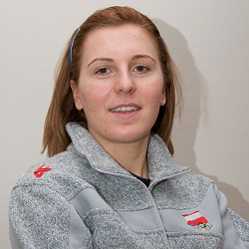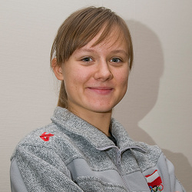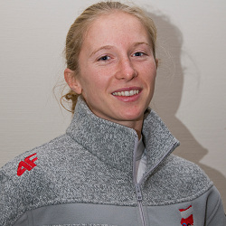
PB :
500m 40,25 28 November 2009 Calgary (CAN)
1500m 1.57,87 12 December 2009 Salt Lake City (USA)
3000m 4.14,76 4 December 2009 Calgary (CAN)
5000m 7.48,60 26 January 2008 Hamar (NOR)
2011/2012:
500m 41,03 15 October 2011 Inzell (GER)
1500m 2.00,83 16 October 2011 Inzell (GER)
3000m 4.15,58 25 November 2011 Astana (KAZ)
Katarzyna Woźniak (05.10.1989)
OG:
2010. 3. Team Pursuit
PB:
500m 40,16 22 March 2009 Calgary (CAN)
1500m 1.58,84 12 December 2009 Salt Lake City (USA)
3000m 4.09,42 4 December 2009 Calgary (CAN)
5000m 7.37,80 18 February 2011 Salt Lake City (USA)
2011/2012:
500m 41,35 29 October 2011 Erfurt (GER)
1500m 2.01,61 16 October 2011 Inzell (GER)
3000m 4.17,29 25 November 2011 Astana (KAZ)
Luiza Złotkowska (25.05.1986)
OG:
2010. 3. team pursuit
PB:
500m 39,96 12 February 2011 Calgary (CAN)
1500m 1.56,81 19 February 2011 Salt Lake City (USA)
3000m 4.07,58 12 February 2011 Calgary (CAN)
5000m 7.07,02 18 February 2011 Salt Lake City (USA)
2011:2012:
500m 41,80 26 November 2011 Astana (KAZ)
1500m 2.07,15 16 December 2011 Zakopane (POL)
3000m 4.28,99 17 December 2011 Zakopane (POL)
5000m 7.28,32 2 December 2011 Heerenveen (NED)
RUSSIA (3)
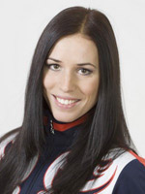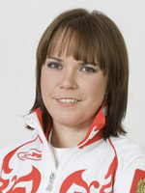
Ekaterina Lobisheva (13.03.1985, Kolomne)
OG:
2006. 3. team pursuit, 11. 1000, 6. 1500
2010: 28. 1000, 11. 1500, 7. team pursuit
PB:
500m 38,56 28 February 2009 Salt Lake City (USA)
1500m 1.54,87 19 February 2011 Salt Lake City (USA)
3000m 4.08,12 12 February 2011 Calgary (CAN)
5000m 7.24,36 23 December 2011 Moscow (RUS)
2011/2012:
500m 38,96 22 December 2011 Moscow (RUS)
1500m 1.57,91 3 December 2011 Heerenveen (NED)
3000m 4.12,08 25 November 2011 Astana (KAZ)
5000m 7.24,36 23 December 2011 Moscow (RUS)
Olga Graf (15.07.1983)
PB:
500m 41,04 22 December 2011 Moscow (RUS)
1500m 2.00,18 22 November 2009 Hamar (NOR)
3000m 4.09,97 25 November 2011 Astana (KAZ)
5000m 7.12,80 29 October 2011 Kolomna (RUS)
2011/2012:
500m 41,04 22 December 2011 Moscow (RUS)
1500m 2.00,41 23 December 2011 Moscow (RUS)
3000m 4.09,97 25 November 2011 Astana (KAZ)
5000m 7.12,80 29 October 2011 Kolomna (RUS)
Yulia Skokova (01.12.1982, Sverdlovsk)
PB:
500m 39,57 17 November 2007 Calgary (CAN)
1500m 1.57,20 3 December 2011 Heerenveen (NED)
3000m 4.08,40 4 December 2009 Calgary (CAN)
5000m 7.30,38 11 January 2004 Heerenveen (NED)
2011/2012:
500m 39,59 30 October 2011 Kolomna (RUS)
1500m 1.57,20 3 December 2011 Heerenveen (NED)
3000m 4.14,00 18 November 2011 Tsjeljabinsk (RUS)
5000m 7.37,24 23 December 2011 Moscow (RUS)
SUISSE
Kaitlyn McGregor (03.03.1994)
PB: 500m 40,22 19 March 2011 Calgary (CAN)
1500m 2.01,88 15 March 2011 Calgary (CAN)
3000m 4.20,53 16 March 2011 Calgary (CAN)
5000m 8.39,14 21 December 2008 Inzell (GER)
2011/2012:
500m 41,55 29 December 2011 Inzell (GER)
1500m 2.05,96 3 December 2011 Heerenveen (NED)
3000m 4.35,26 12 November 2011 Erfurt (GER)
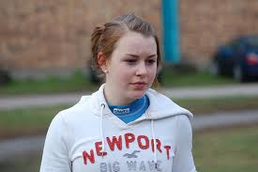
SUB.
BELGIUM
Jelena Peeters (19.12.1985) .
PB:
500m 41,55 30 December 2011 Erfurt (GER)
1500m 2.05,58 17 November 2011 Heerenveen (NED)
3000m 4.19,52 15 December 2011 Heerenveen (NED)
5000m 7.16,55 30 December 2011Erfurt (GER)
2011/2012:
500m 41,55 30 December 2011 Erfurt (GER)
1500m 2.05,58 17 November 2011 Heerenveen (NED)
3000m 4.19,52 15 December 2011 Heerenveen (NED)
5000m 7.16,55 30 December 2011 Erfurt (GER)
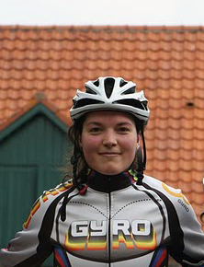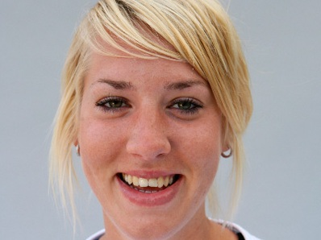
NEEDERLAND
Jorien Voorhuis (26.08.1984)
OG:
2010 Vancouver 10. 5000, 6. Team Pursuit
WCH: Junioren
2003 1. Team Pursuit
2004 1. Team Pursuit
ECH: Allround
2011 Heerenveen 5
WCH: Allround
2009 Hamar 5, 2010 Heerenveen 6, 2011 Calgary 6
WCH:
2008 Nagano 11. 1500
2009 Richmond 4. 3000, 10. 5000, 2. Team Pursuit
PB:
500m 39.16 Calgary 12-02-2011
1500m 1.55.2 Calgary 13-02-2011
3000m 4.01.75 Salt Lake City 06-03-2009
5000m 6.59.23 Calgary 13-02-2011
2011/2012:
500m 40,20 17 December 2011 Erfurt (GER)
1500m 2.00,33 6 November 2011 Heerenveen (NED)
3000m 4.10,88 27 December 2011 Heerenveen (NED)
5000m 7.12,35 30 December 2011 Heerenveen (NED)
POLSKA
Karolina Domańska-Ksyt (31.05.1985)
PB:
500m 40,50 16 November 2007 Calgary (CAN)
1500m 2.03,74 28 October 2007 Calgary (CAN)
3000m 4.17,79 16 November 2007 Calgary (CAN)
5000m 7.29,58 1 December 2007 Kolomna (RUS)
2011/2012:
500m 42,40 15 October 2011 Inzell (GER)
1500m 2.05,82 16 October 2011 Inzell (GER)
3000m 4.23,48 18 November 2011 Tsjeljabinsk (RUS)
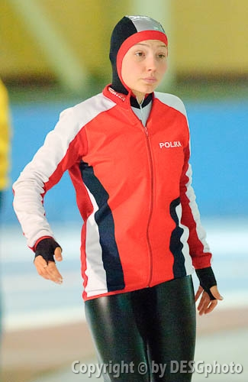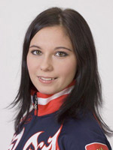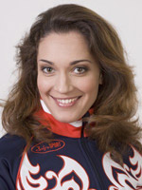
RUSSIA
Evgenia Dmirtieva (08.09.1990)
PB:
500m 40,10 24 December 2011 Moscow (RUS)
1500m 1.57,46 3 December 2011 Heerenveen (NED)
3000m 4.07,29 25 November 2011 Astana (KAZ)
5000m 7.14,57 2 December 2011 Heerenveen (NED)
2011/2012:
500m 40,10 24 December 2011 Moscow (RUS)
1500m 1.57,46 3 December 2011 Heerenveen (NED)
3000m 4.07,29 25 November 2011 Astana (KAZ)
5000m 7.14,57 2 December 2011 Heerenveen (NED)
Ekaterina Sihova (25.06.1985, Sank Petersburg)
OG: 2010: 11. 1000, 8. 1500, 7. team Pursuit
PB:
500m 38,40 30 January 2010 Calgary (CAN)
1500m 1.54,78 12 December 2009 Salt Lake City (USA)
3000m 4.11,55 12 February 2011 Calgary (CAN)
5000m 7.20,69 21 March 2010 Heerenveen (NED)
2011/2012:
500m 39,17 30 October 2011 Kolomna (RUS)
1500m 1.57,17 3 December 2011 Heerenveen (NED)
3000m 4.12,86 25 November 2011 Astana (KAZ)
5000m 7.36,18 29 October 2011 Kolomna (RUS)

